**Project Description:**

The Mumble app is an Android application designed to assist students at Mapúa Malayan Colleges Mindanao (MMCM) who are struggling to form social connections. The primary users are irregular students, students who have shifted courses, and transfer students. The app aims to facilitate the formation of friendships and social integration within the college environment.

**Requirements Summary:**

|  |  |  |  |
| --- | --- | --- | --- |
|  | Processor Cores | Single Core |  |
| **MINIMUM REQUIREMENTS** |  |  |  |
| OS | Android 4.4 (KitKat) |  |
|  |  |
|  |  |  |  |
|  | RAM | 2 GB |  |
|  |  |  |  |
|  | Processor Cores | Quad Core |  |
| **RECOMMENDED REQUIREMENTS** |  |  |  |
| OS | Android 8.0(Oreo) |  |
|  |  |
|  |  |  |  |
|  | RAM | 4 GB |  |
|  |  |  |  |
| **OTHER REQUIREMENTS** | Permissions | Notifications and Storage |  |
|  |  |  |  |

Table 1. System Requirements

The Mumble app is designed to be lightweight and accessible, with minimum system requirements to cater to a wide range of Android devices. The app requires Android 4.4 (KitKat) or later, at least 2 GB of RAM, and a single-core processor. For optimal performance, it is recommended to use a device with Android 8.0 (Oreo) or later, at least 4 GB of RAM, and a quad-core processor.

**Prototype Description:**

The prototype of the Mumble app was created using Figma, an interactive prototyping tool. The prototype showcases the app’s main features, including group interaction, chat, alerts, event calendar, and user profile. It also demonstrates the user-friendly interface and easy navigation of the app.

**MUMBLE Figma Link**:

<https://www.figma.com/design/Gjg68i1bIlRd7BXysZHPTQ/Main?node-id=0-1&t=E6b5vy0PWTitPN6P-0>

**User Scenario:**

Consider a student named Alex, who recently transferred to MMCM. Alex is finding it difficult to form social connections in his new environment. He discovers the Mumble app and decides to give it a try. Using the app, Alex can join groups that match his interests, participate in group chats, and attend social events organized by them. Over time, Alex forms meaningful friendships and feels more integrated into the college community.

**Mockup/Prototype:**

**Sign In**

The Sign In page displayed upon first launch. This is to facilitate authentication.

**Sidebar**

The Sidebar that opens upon tapping the home icon. The top section display individual persons while the bottom section displays joined groups with an option for group exploration (the plus icon).

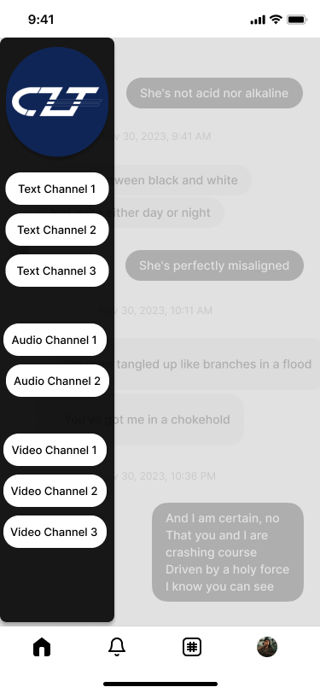

**Group Channel Navigation**

Upon tapping a group’s icon, the previous sidebar retracts to be replaced by another offering channel navigation.

**Group Discovery**

The Group Discovery Screen offers a way to showcase various interest-based groups.

**Group Search**

The Group Search Screen offers a way to search through interest-based groups.

**Group Page**

The Group Page Screen shows an elaboration providing details of a specific group.

**Chat**

The Chat Screen facilitates real-time communication between users in the app.

**Alerts**

The Alerts Screen provides a union of information from announcements provided in each joined group.

**Event Calendar**

The Event Calendar provides a comprehensive overview of organized events hosted by each joined group.

**User Profile**

The User Profile Screen offers users high customizability to personalize their profiles by adding text, images, achievements, interests, and more.

**Prototype Flow**:

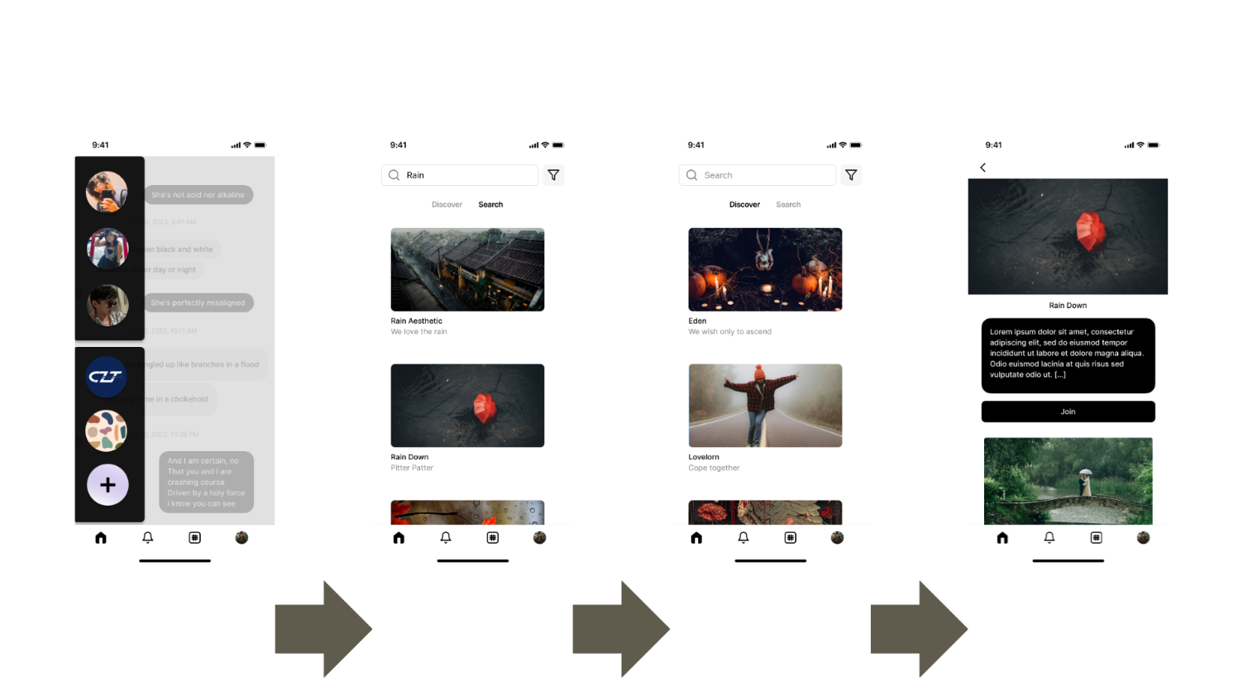

Figure 3.1 Navigating the Tab Bar

Figure 3.2 Group Functionalities A screenshot of a phone

Description automatically generated

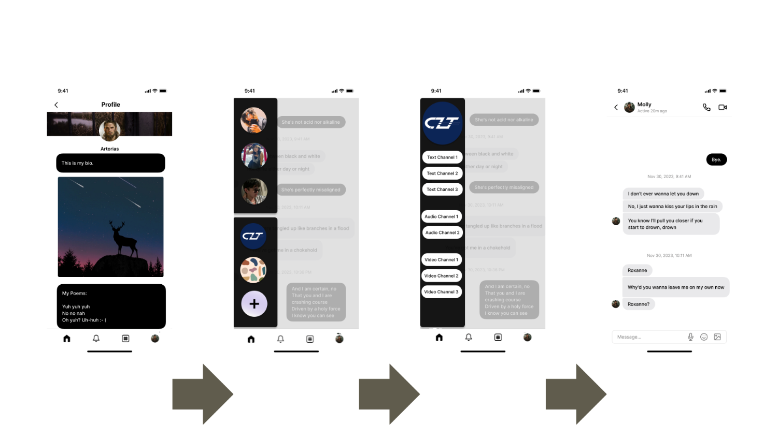Figure 3.3 Chat Functionalities

**Rationale:**

The Mumble app is designed to address the social challenges faced by irregular students, course shifters, and transfer students at MMCM. By providing a platform for these students to connect and interact, the app aims to reduce feelings of isolation and improve the overall college experience. Figma is an interactive platform that is free to use and allows team members to collaborate on editing the prototype, which is why the team decided to utilize it to build it. Figma also allows the team to present the application's initial mockups and final design. Furthermore, it provides excellent convenience for displaying and sharing prototypes with remote users, as well as easy adjustments based on feedback.

**Changes to the Requirements:**

While there were no specific alterations to the system requirements, significant modifications were made to the prototype's usability criteria. These updates aim to enhance the overall user experience and ensure the prototype meets high usability standards. The revised designs will now incorporate the principles of the 10 Usability Heuristics, including elements such as Minimalist Design, Recognition, Flexibility, Freedom, and Consistency. By integrating these heuristics, the prototype will become more intuitive, efficient, and user-friendly, ultimately providing a better experience for end-users.

**Initial Evaluation Plan:**

The initial evaluation of the Mumble app will involve usability testing with a small group of users. The users will be asked to complete a series of tasks using the app, and their interactions with the app will be observed and recorded. Feedback will be collected through interviews and surveys.

**Usability Specifications**

The creation of this prototype aims to achieve the following criteria to enhance user experience:

* **Effectiveness**: This measure will demonstrate how well the prototype performs the required tasks.
* **Efficiency**: This will indicate how easily and smoothly the prototype can be used.
* **Utility**: This will confirm that the prototype supports appropriate functions and alternatives for specific tasks.
* **Learnability**: This will highlight how quickly users can learn to use the prototype system.
* **Memorization**: This will show how easily users can remember the steps for using the system.

**Population**

To validate the Mumble prototype against its defined requirements, a user test will be conducted with 10-15 college students. Participants will complete specific tasks designed to assess each requirement.

**Prototype Tasks**

With the Mumble app, users can join groups, participate in group chats, attend social events, and personalize their profiles.

* **App Navigation** – Users should navigate through various tabs, including Groups, Alerts, Event Calendar, and User Profile.
* **Group Channel Interaction –** Users should be able to join and interact with groups.
* **Event CalendarExploration –** Users should be able to explore scheduled hangouts, meetings, and other activities.
* **Update User Profile –** Users should be able to edit and update their profile details.

Roles Figure 3.3 Chat Functionalities

The team will recruit a minimum of 10 participants for this evaluation. To ensure balance, the team will divide the participants and assign them comparable roles.

|  |  |
| --- | --- |
| **Developer / UI Designer Member** | **Task(s)** |
| Ed Chryssha U. Cordero | This member will record how well each participant performs their tasks, the time spent on each task, and take notes on the users' experiences. |
| Fritz Gerald M. Latagan | This member will record how well each participant performs their tasks, the time spent on each task, and take notes on the users' experiences. |
| Nur Fyed L. Tamburani | This member will record how well each participant performs their tasks, the time spent on each task, and take notes on the users' experiences. |

Table 2. Team Member Tasks

**Heuristic Evaluation**

Evaluation of MUMBLE will also use the 10 Usability Heuristic method of Evaluation.

*Visibility of System Status*

The prototype ensures participants are consistently informed about its current status and activities.

*Match Between System and Real World*

The prototype uses clear, familiar English words and phrases, avoiding complex jargon. It follows real-world conventions to present information in a natural and logical order.

*User control and Freedom*

The prototype includes clearly marked prompts such as "Are you sure?" to confirm critical actions like leaving a group or deleting an account, giving users control to prevent mistakes.

*Consistency and Standards*

The prototype maintains consistency and provides relevant information to enhance the user's experience without causing confusion.

*Error Prevention*

The prototype strategically places error messages to prevent problems before they occur.

*Recognition rather than recall*

The prototype's features are intuitive, making them easy for users to understand and remember.

*Flexibility and Efficiency of Use*

The prototype accommodates both experienced and inexperienced users, allowing for customization of frequent actions. Its functions are self-explanatory.

*Aesthetic and Minimalist Design*

The prototype maintains a consistent design and aesthetic, avoiding unnecessary details. Every element serves a purpose.

*Help Users Recognize, Diagnose, and Recover from Errors*

Error messages are clear and precise, identifying problems and providing constructive solutions.

*Help and Documentation*

This information is easy to search for. Help can easily be accessible, and documentation is straightforward.

**Participant Survey and Feedback**

**After conducting the online test,**

|  |  |
| --- | --- |
| **DATA GATHRERING** | **DESCRIPTION** |
| **METHOD** |  |
| Survey (Quantitative) | After the Online Testing, the team will be handing out a survey to |
|  | the participants to gather data for the user’s experience with the |
|  | prototype which the team will be interpreting in a 5-point Likert |
|  | scale (**Refer to Table 5**. **5-Point Likert Scale Interpretation**). |
|  |  |
| Feedback (Qualitative) | The survey that the team provided will support a Feedback section |
|  | to help users/participants speak out concerns or issues with the |
|  | prototype that needs to be addressed. |

Table 3. Data Gathering Methods

The table above showcases the three (3) different data gathering methods the team will be using while conducting the online test of the MUMBLE Prototype.

|  |  |  |  |
| --- | --- | --- | --- |
| **SECTION 1** | | | |
| **Question** | **Mean** | **Interpretation** | **Classification** |
| On a scale of 1 to 5, how would you rate the visibility of system status in the MUMBLE app? | 5-Point Scale | | |
| On a scale of 1 to 5, how well did the MUMBLE app’s language and design match with your real-world expectations? |
| On a scale of 1 to 5, how in control did you feel in while using the MUMBLE app? Were the “Cancel” and “Back” options helpful? |
| On a scale of 1 to 5, how consistent did you find the navigation and design standards in the MUMBLE app? |
| On a scale of 1 to 5, how easy was it to prevent or correct errors you encountered while using the MUMBLE app? |
| **SECTION 2** | | | |
| On a scale of 1 to 5, how effective was the recognition over recall design in helping you use the MUMBLE app? | 5-Point Scale | | |
| On a scale of 1 to 5, how would you rate the flexibility and efficiency of use for new versus experienced users? |
| On a scale of 1 to 5, how do you rate the aesthetic and minimalist design of the MUMBLE app? |
| On a scale of 1 to 5, when encountering errors, how clear were the indicators, and did they assist you in understanding what to do next? |
| **SECTION 3** | | | |
| Overall, on a scale of 1 to 5, how satisfied are you with your experience using the MUMBLE app? | Short Answer | | |

Table 4. Survey Questionnaire

The table above outlines the questions included in the survey for this prototype. Participants will receive the survey link after the test. You can view the survey using this link: <https://docs.google.com/forms/d/e/1FAIpQLSfZRbwDkV4Wk09wQgmXl2ktZoBdlkSBNv-VgQdmnYVeRRykBw/viewform?usp=sf_link>

|  |  |  |  |
| --- | --- | --- | --- |
| **Scale** | **Range Value** | **Interpretation** | **Classification** |
| 5 | 4.50-5.00 | Highly Acceptable |  |
|  |  |  | Successful |
| 4 | 3.50-4.49 | Acceptable |  |
| 3 | 2.50-3.49 | Moderately Acceptable | Neutral |
|  |  |  |  |
| 2 | 1.50-2.49 | Fairly Acceptable |  |
|  |  |  | Unsuccessful |
| 1 | 1.00-1.49 | Not Acceptable |  |

Table 5. 5-Point Likert Scale Survey Interpretation

Table 5 represents the Interpretation of the survey questions given to the participants. The survey will be used as to interpret whether the design and features presented are successful and useful for students who suffer from pacing issues.